Task 16 – Selenium Locators

Question 1 :

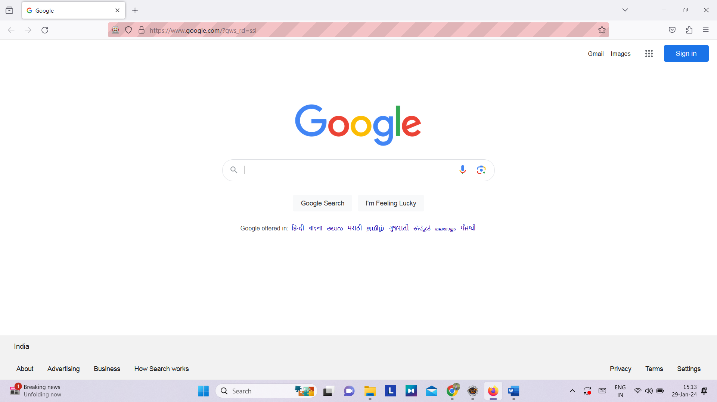

Opening or firefox browser and navigating to <http://google.com>

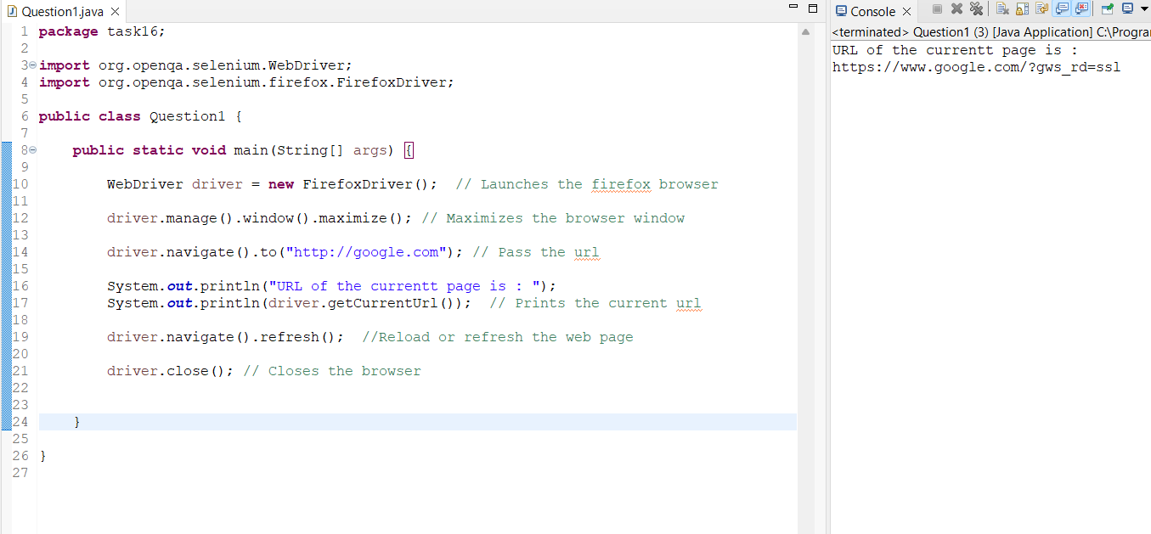

Console output of the URL

Question 2:

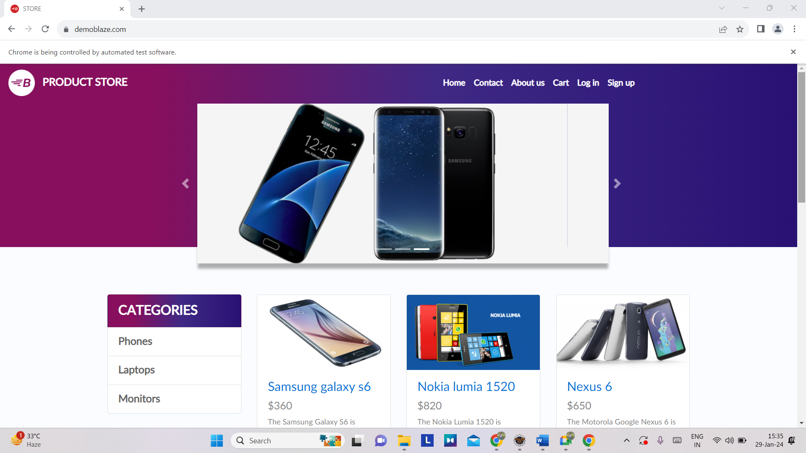

Opening Chrome Browser and navigating to <https://www.demoblaze.com>

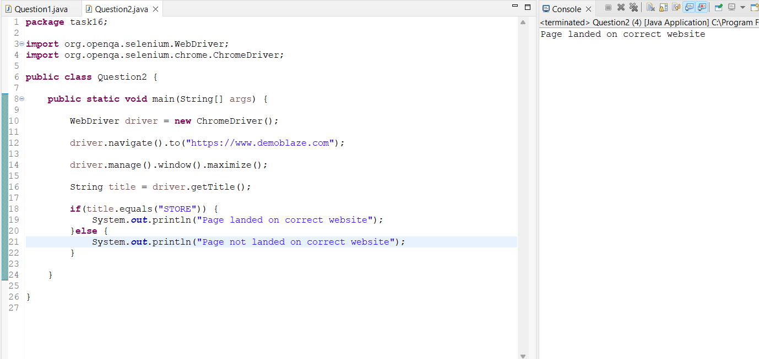

Console output

Question 3:

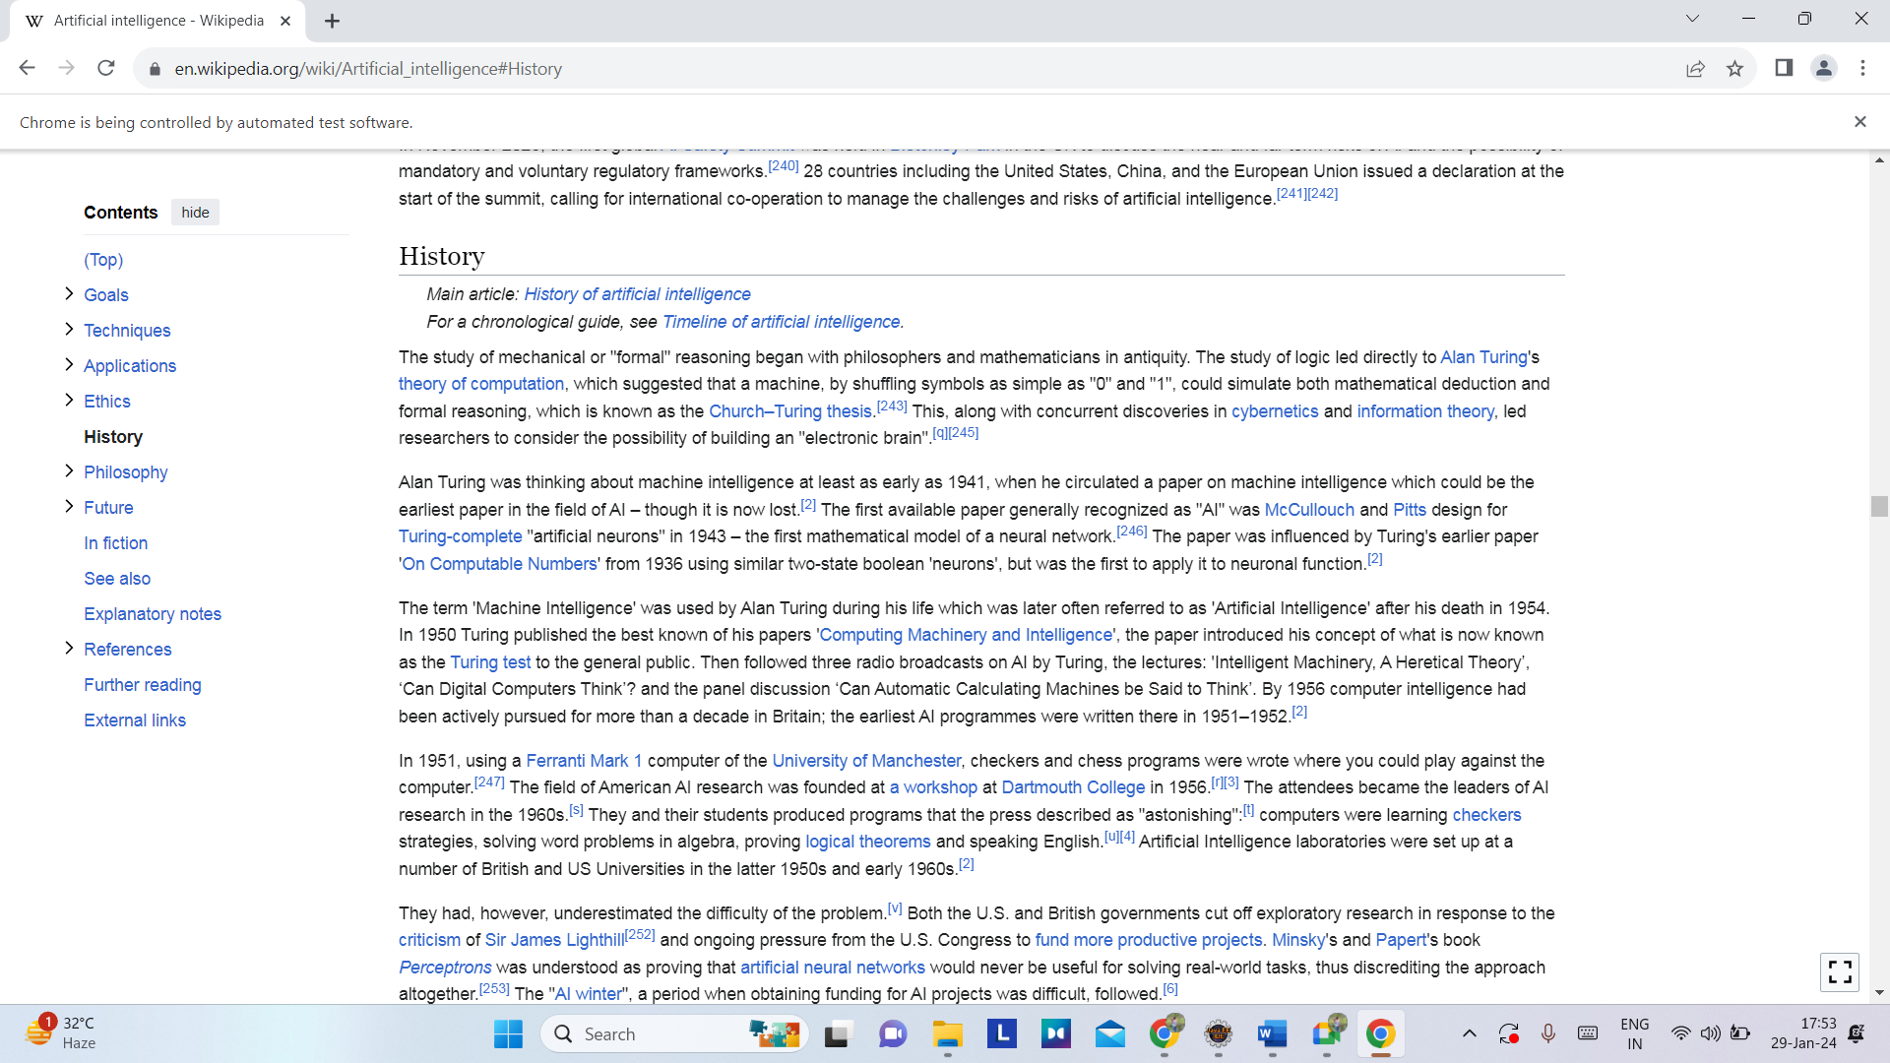

Opening Chrome browser, navigating to Wikipedia website, searching Artificial intelligence, clicking History

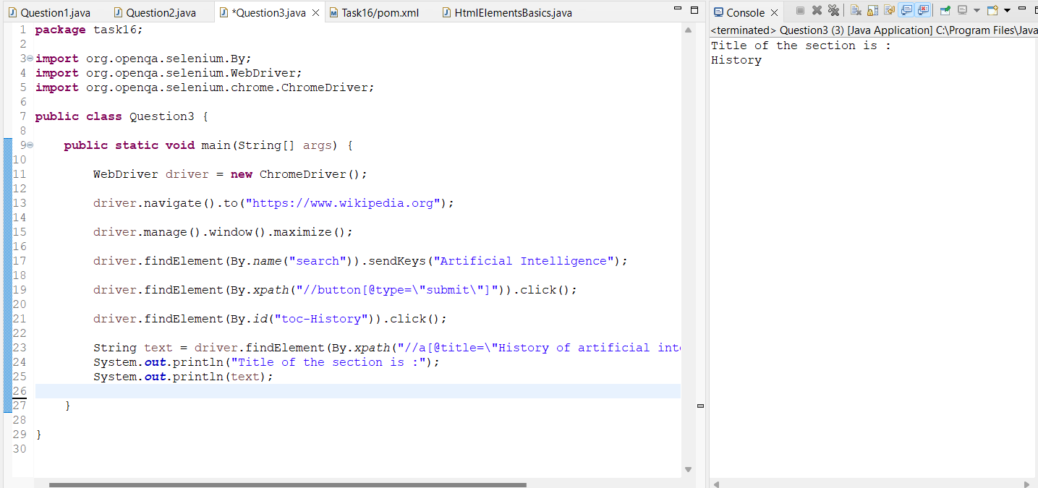

Console output